Harika Jupaka
2403a51l31
B-52
Experiment 6.5: AI-Based Code Completion: Working with
suggestions for classes, loops, conditionals
Task 1: Use an AI tool to generate eligibility logic.
Prompt:
Generate Python code to check voting eligibility based on age and citizenship.

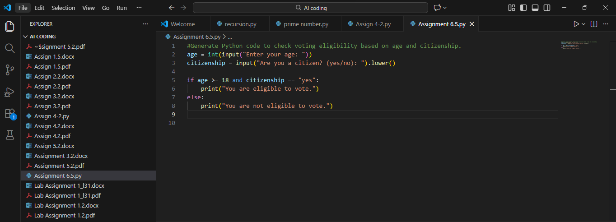
OUTPUT:
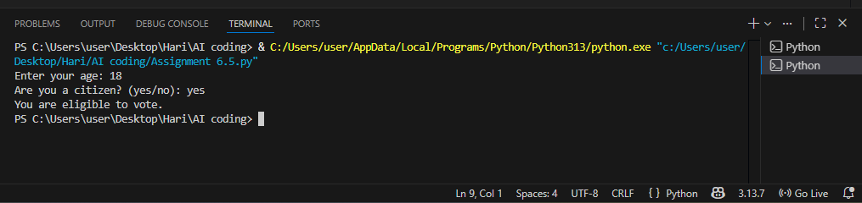

Explanation:
- Age >= 18 checks minimum voting age.
- Citizenship == “Yes” checks nationality.
- Both conditions must be true for eligibility.

Task 2: Count Vowels and Consonants (Loops)

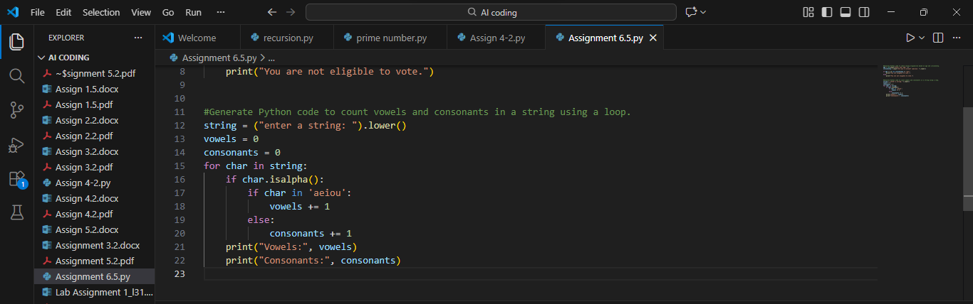
OUTPUT: 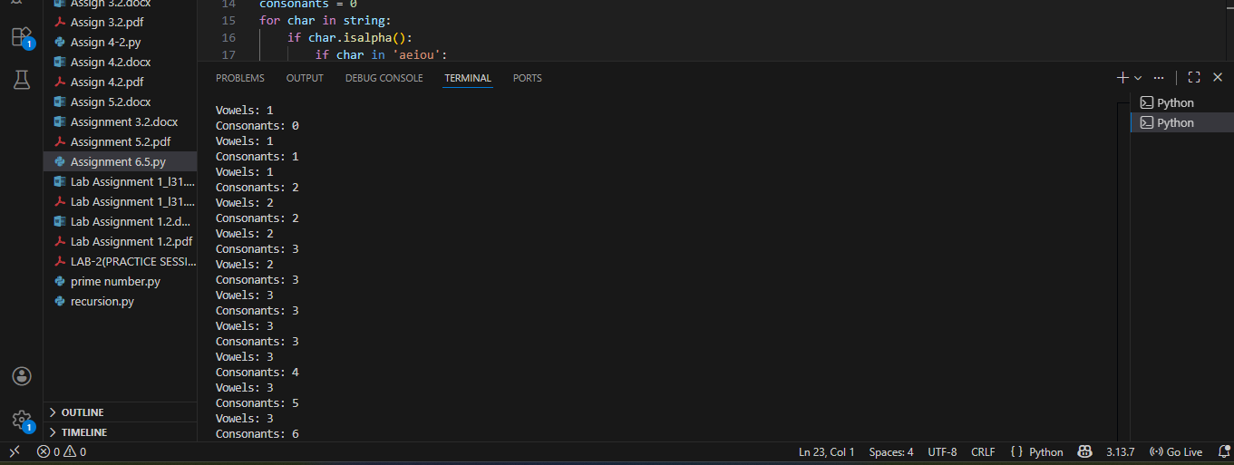

Explanation:
- Loop iterates through each character.
- Isalpha() ensures only letters are counted.
- Vowels and consonants are counted separately.
Task 3: Library Management System (Classes + Loops + Conditionals)
Prompt:
Generate a Python program for a library management system using classes, loops, and conditional statements.
AI-Generated Code:
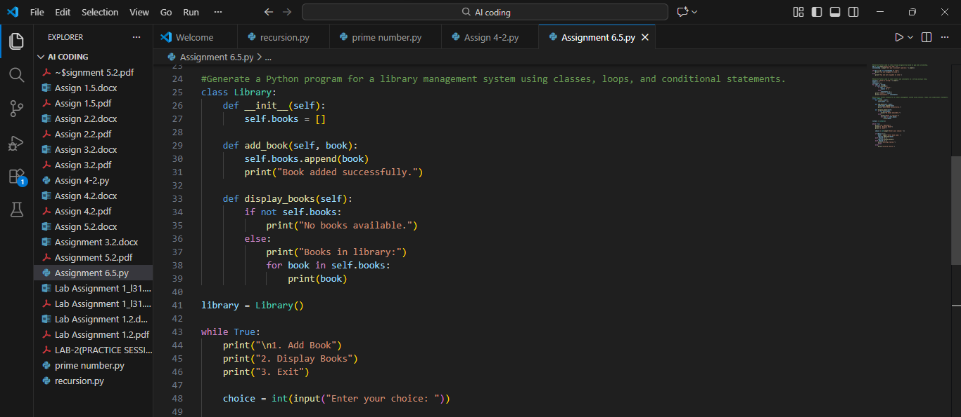
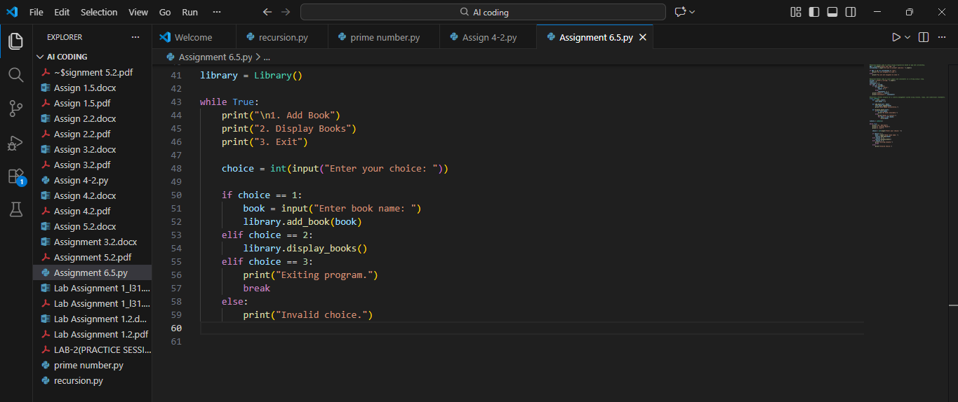

Reflection:
AI helped in generating a structured class-based solution. Manual review improved clarity and error handling.

OUTPUT: 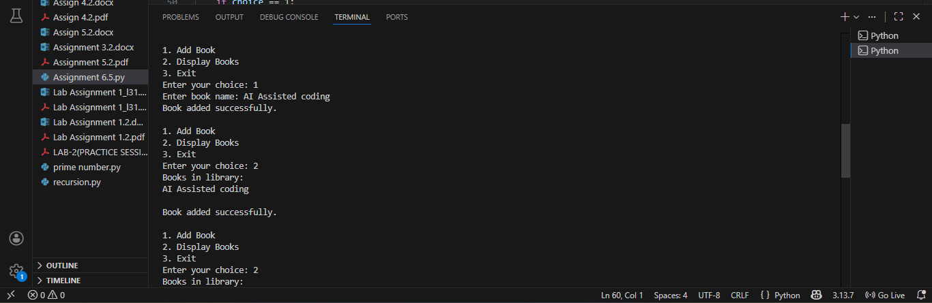

Task 4: Attendance Management System (Class-Based)
Prompt: Generate a Python class to mark and display student attendance using loops.
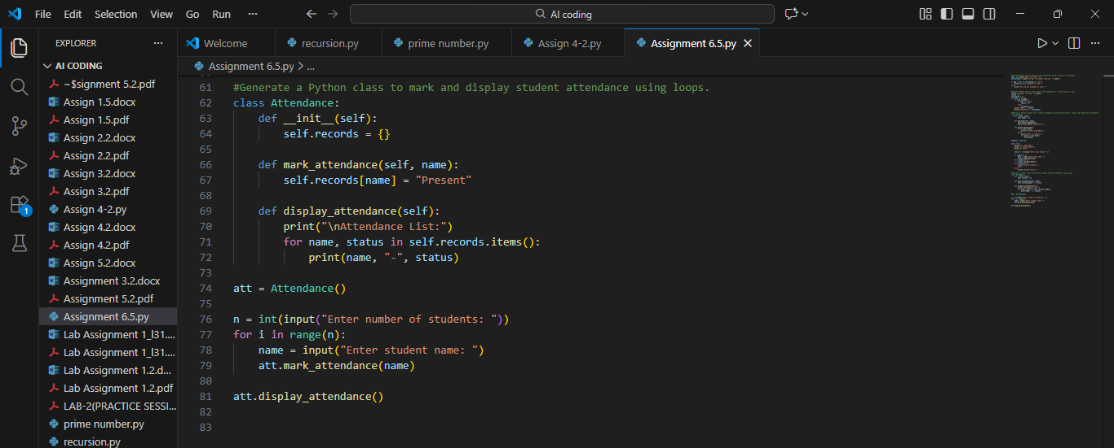
OUTPUT:
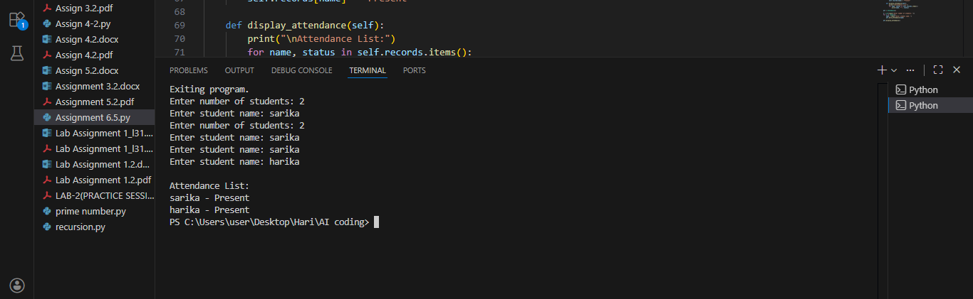
Explanation:
• A dictionary is used to store student names along with their attendance status.
• A loop takes multiple student names as input and displays the attendance clearly.

Task 5: ATM Menu Simulation (Loops + Conditionals)
Prompt: Generate a Python program using loops and conditionals to simulate an ATM menu.
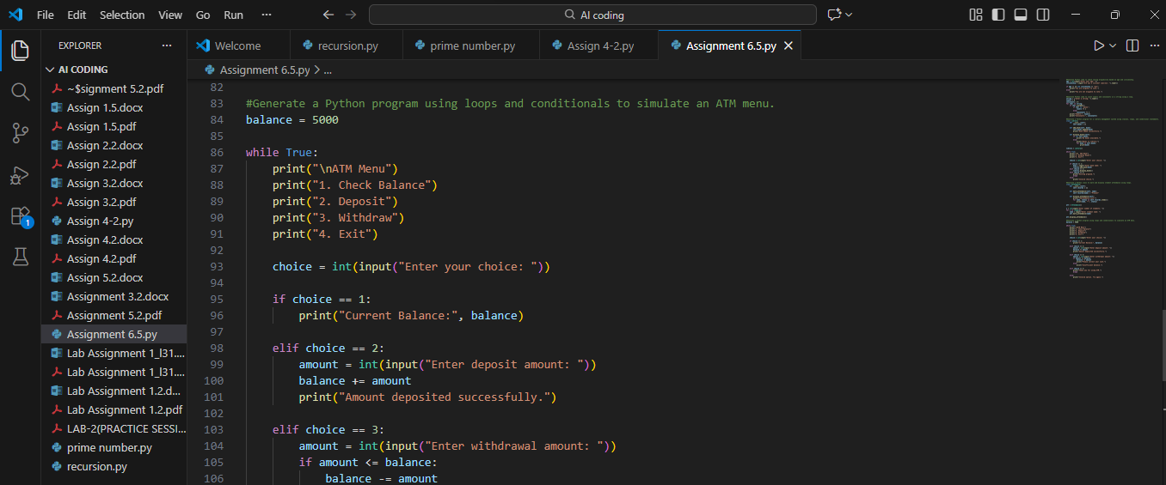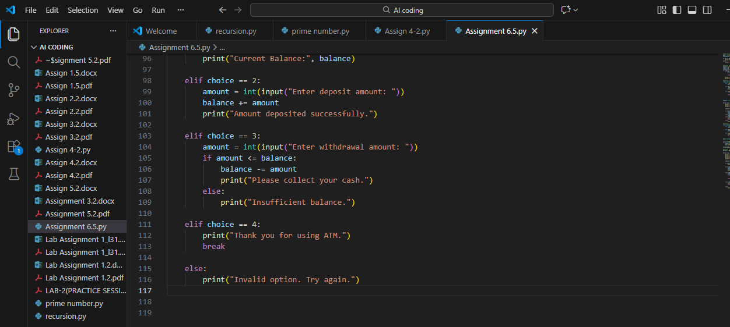
OUTPUT: 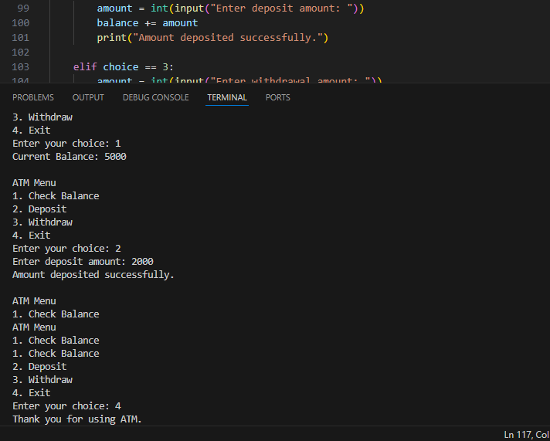

Explanation:
The program displays an ATM menu repeatedly using a while loop until the user chooses to exit.
Conditional statements perform actions like checking balance, depositing money, withdrawing money, and exiting the program.

